* Created temp table ‘transfer_dept_stage’ to insert employee_id and new_department_id ,so multiple employees can be transferred from one department to another.

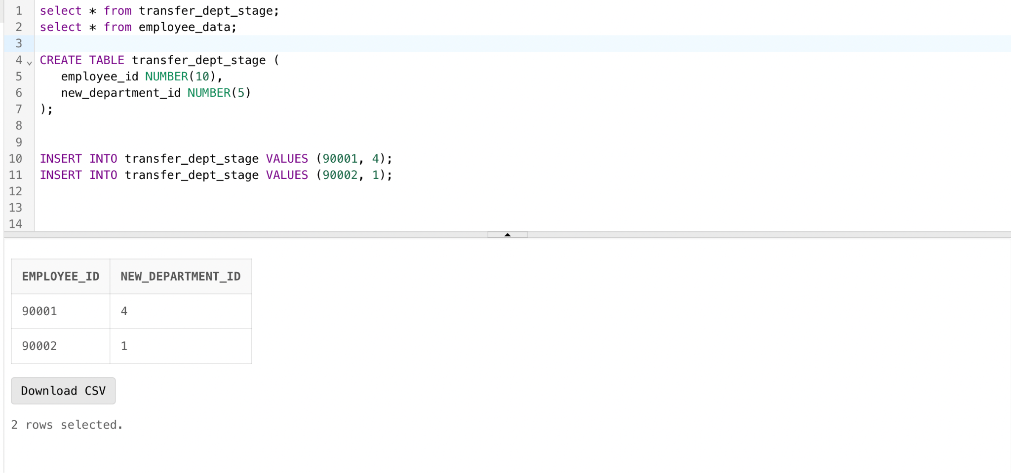

* I have included cursors to fetch the data and exception handling function to demonstrate the error more accurately
* I have used 2 cursors in this PLSQL block

1. check_entry_cursor , to check/count if the staging table has data entry or not
2. transfer_dept_cursor, to fetch employee and department details to be transferred from the staging table

* I have created multiple sceneries to show transfer, types of errors can occur

1. Employees 90001 and 90002 are transferred to a new department 4 and 1. Once the employee departments are transferred ,the data in the table will be deleted as it is a staging table.

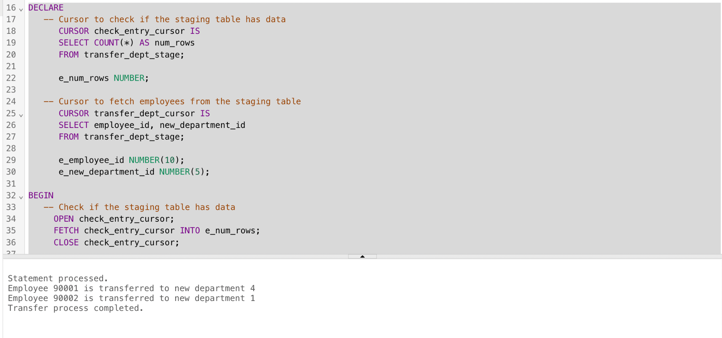

1. As there is no data in the transfer_dept_stage table, cursor check_entry_cursor will check the count of rows in the staging table. If count=0, it will print a ‘no data found’ statement.

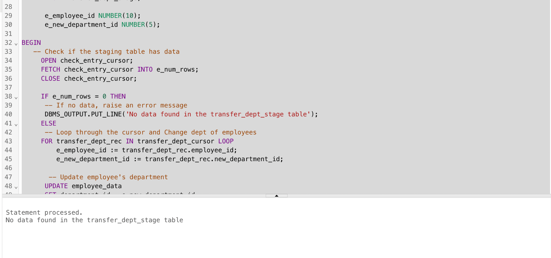

1. If there is a wrong data entry in the staging table, by using ‘SQLERRM’ , we can get an error message corresponding to the error. In this case, I have inserted Employee_id with null value, which should show the error as nothing can be transferred if a new department id is not given.

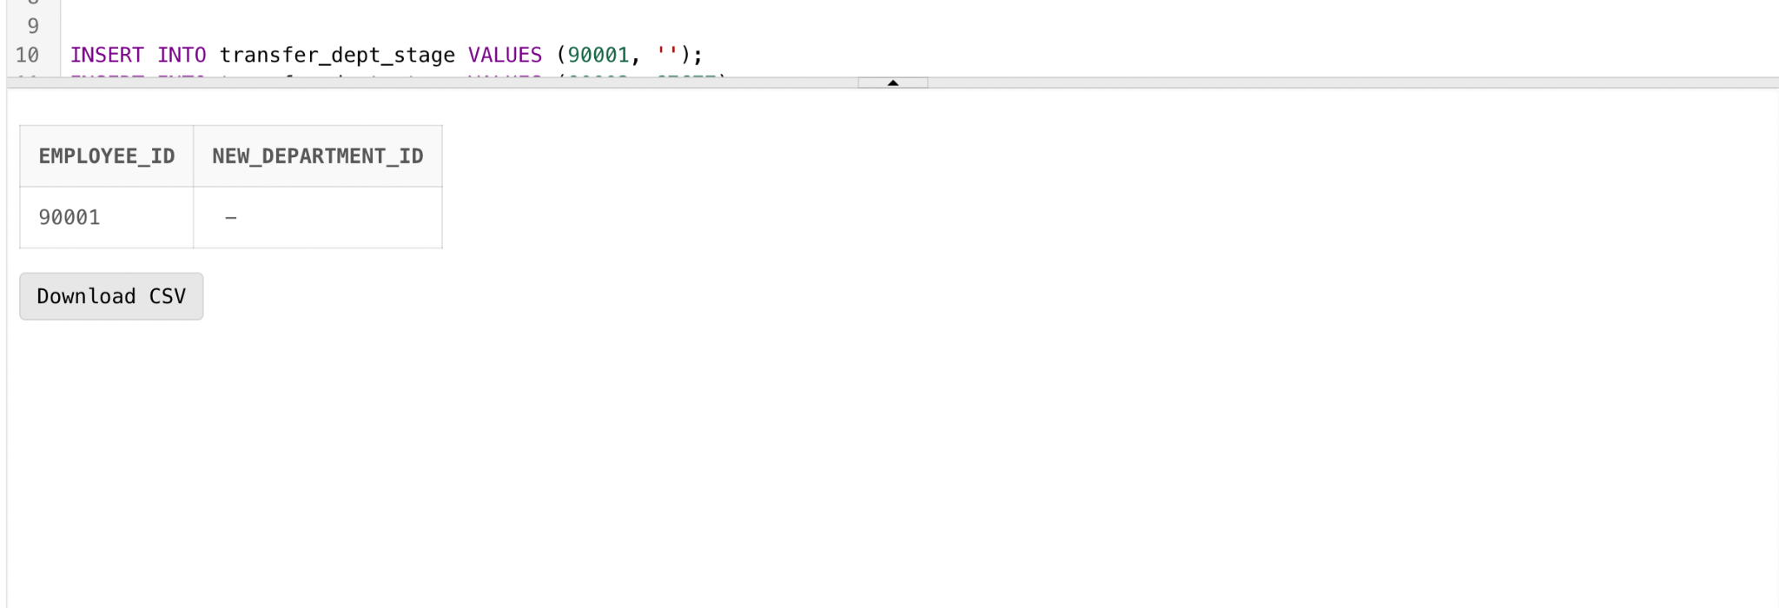

Once the Code runs, we can expect this error

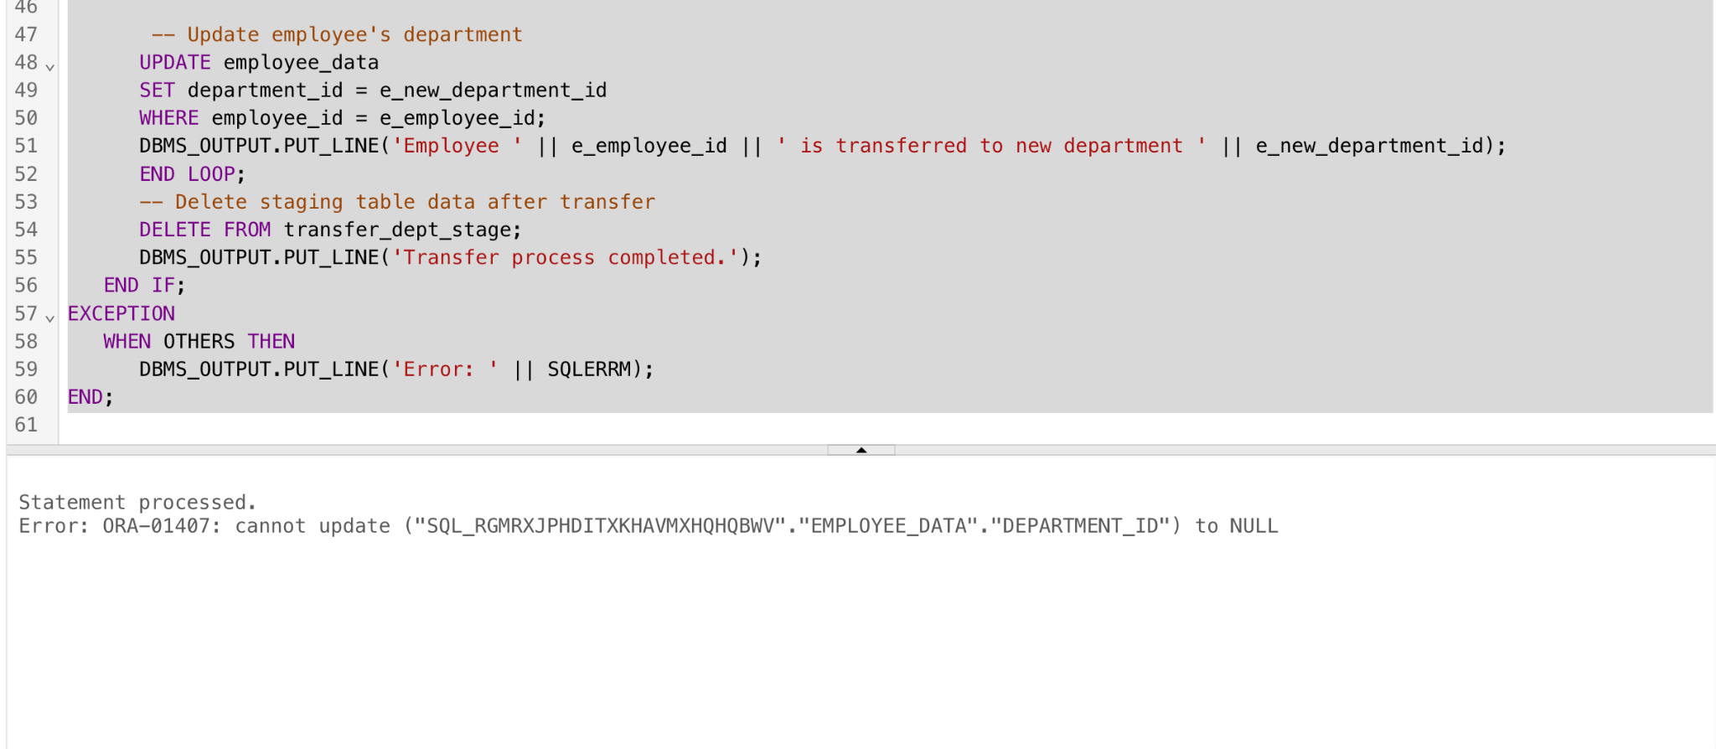

We can get different errors according to the mistake in this built - in exception handling function.